*Name :- Shubham Dutta*

*Class :- 2B*

*Roll No :- 58*

*Enrollment No :- 12019009022112*

*Subject :- Data Base Management*

*System Lab*

*Assignment No -1*

Q1. Create and Insert given data in table customer

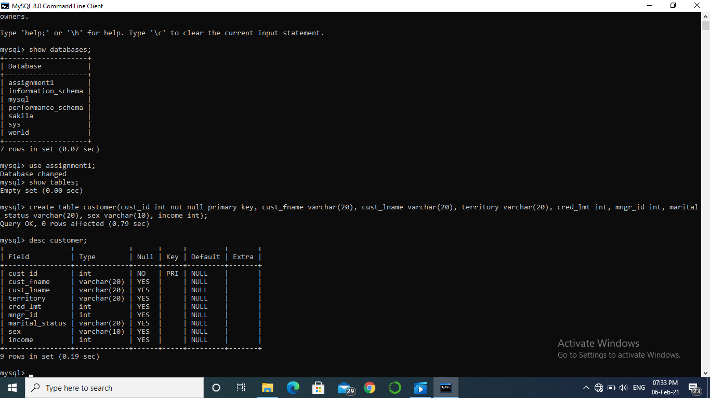

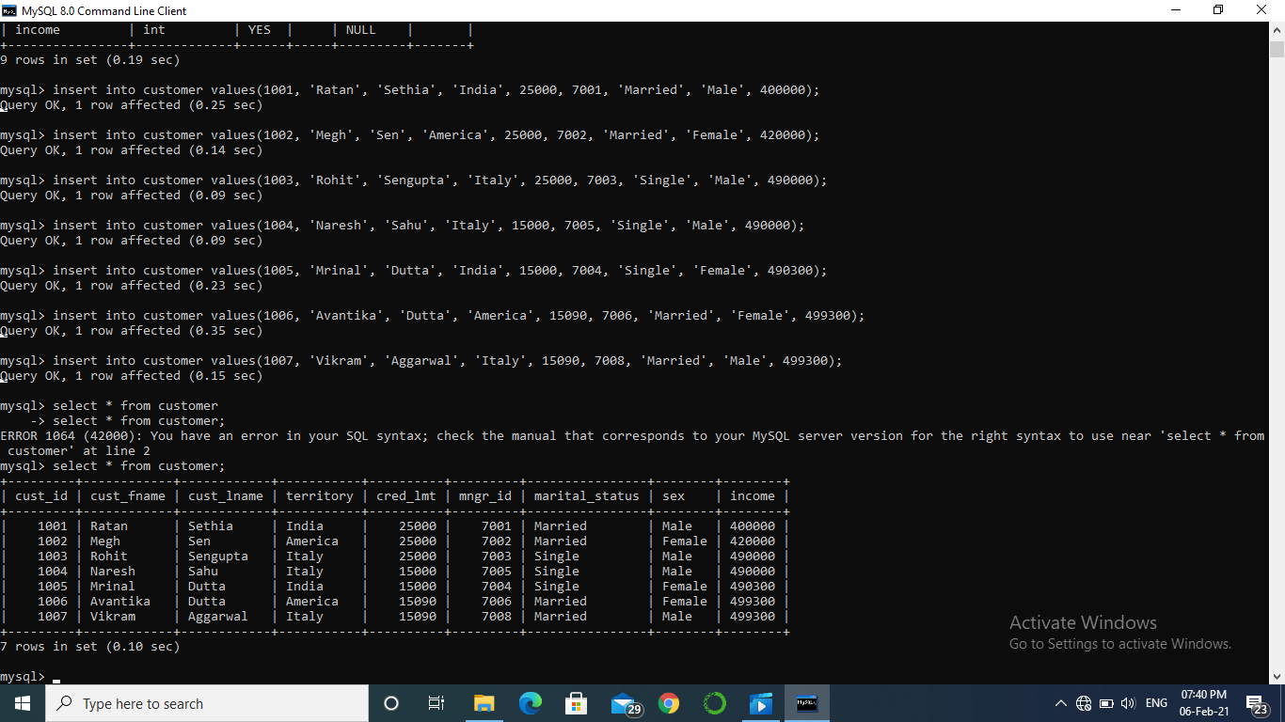

Q2. Alter table and add column stay_from_year

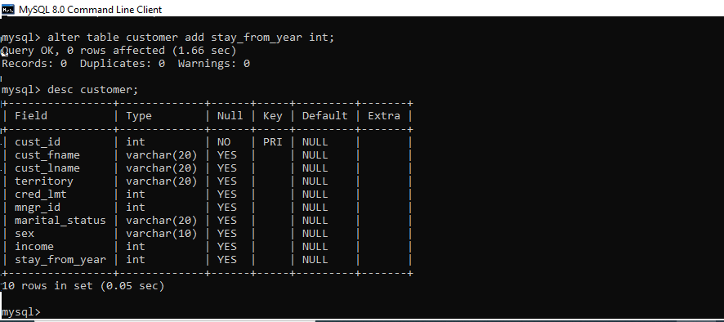

Q3. Set value of stay_from_year as 2001 for Italy.

Q4. Display credit limit attribute for America

Q5. Delete the record corresponding to Meg Sen

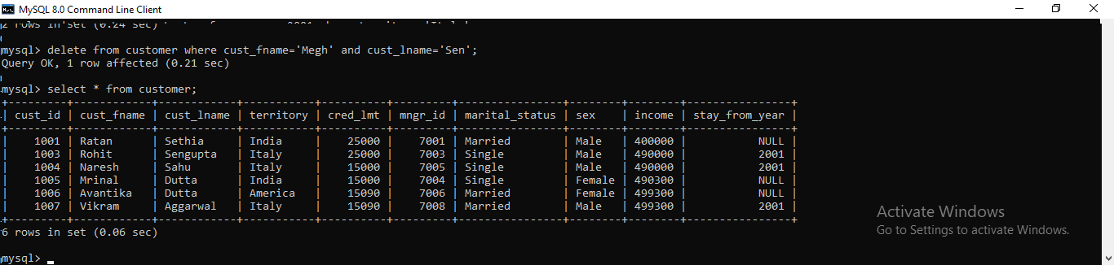

Q6. Show all attributes for Italy

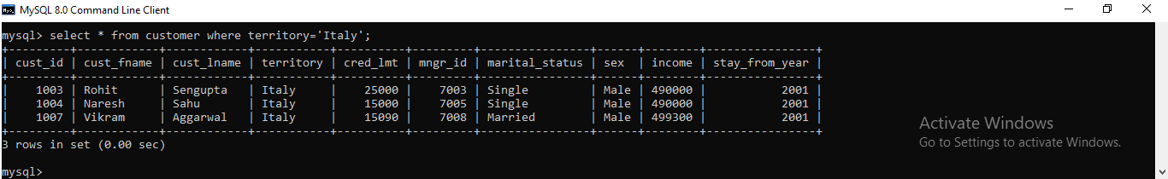

Q7.If territory= India then set value of credit to 7000

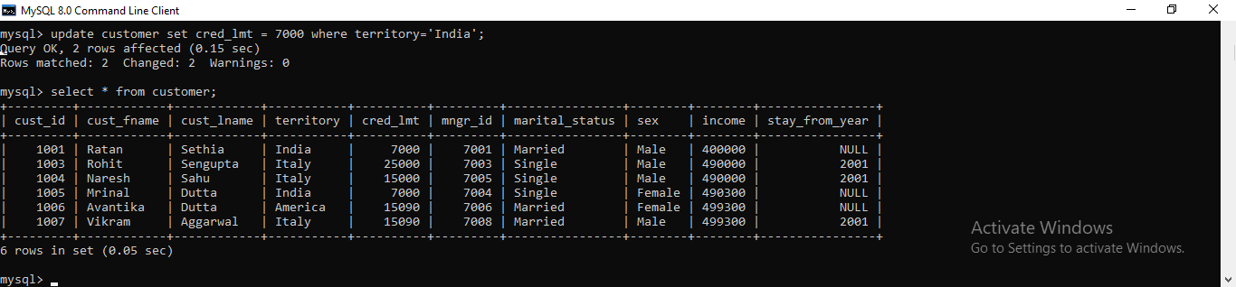

Q8. & Q9. Rename cust_fname to first_name, Rename cust_lname to last_name

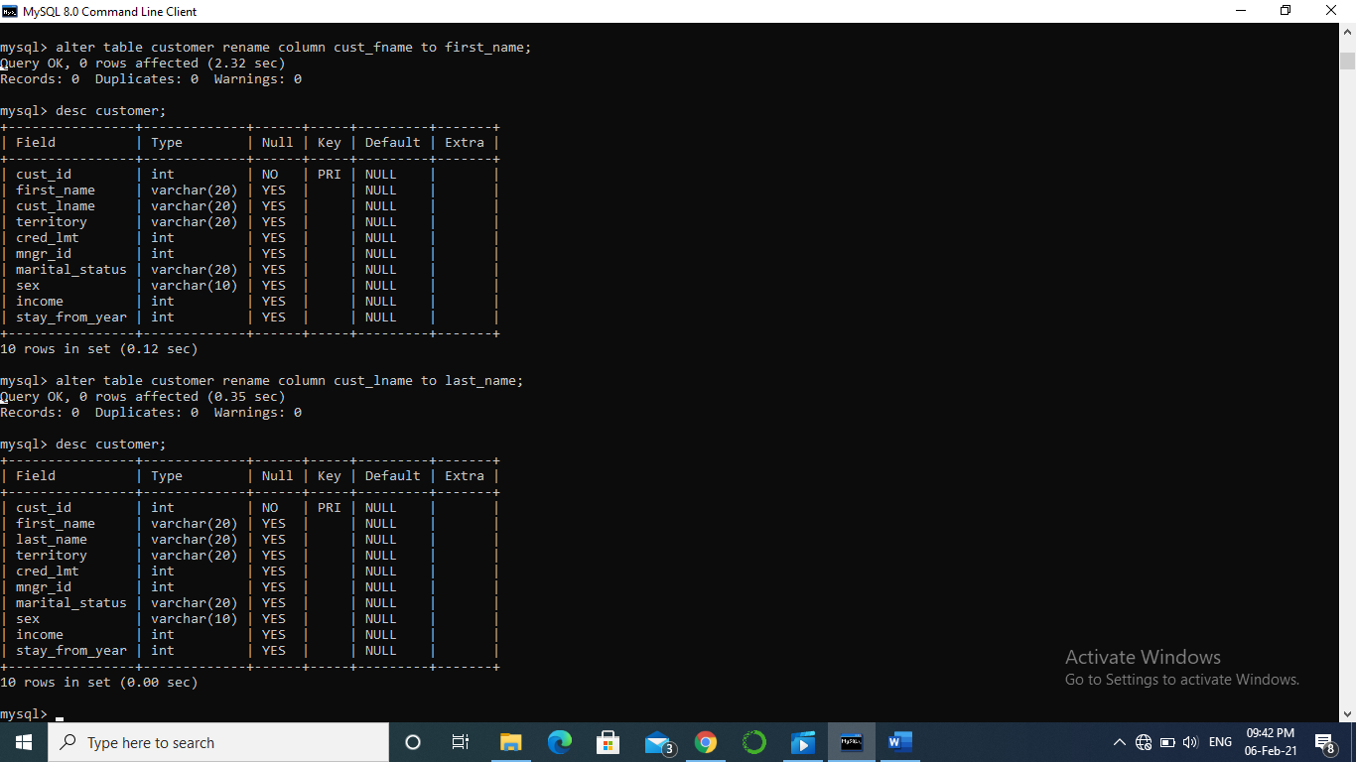

Q10. Create table cust1 from the old table customer (copy structure as well as data using CTAS [create table as select] statement).

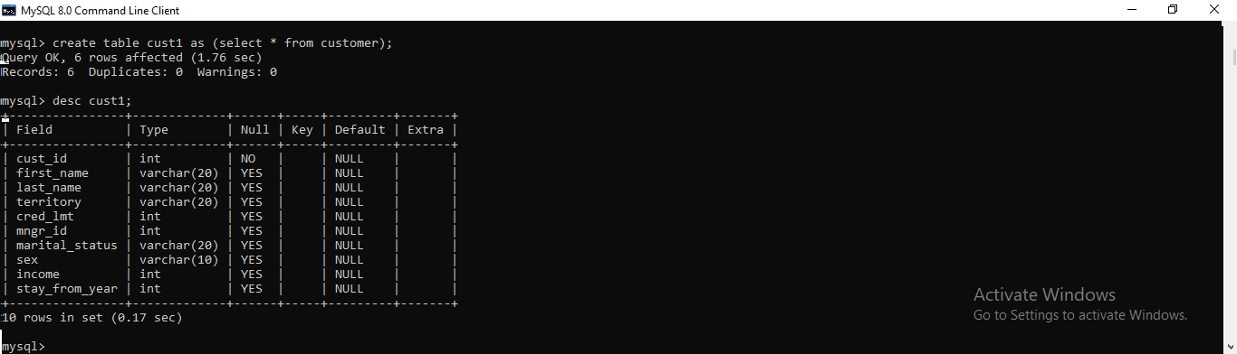

Q11. Create tables cust2 without values of cust1 using CTAS statement

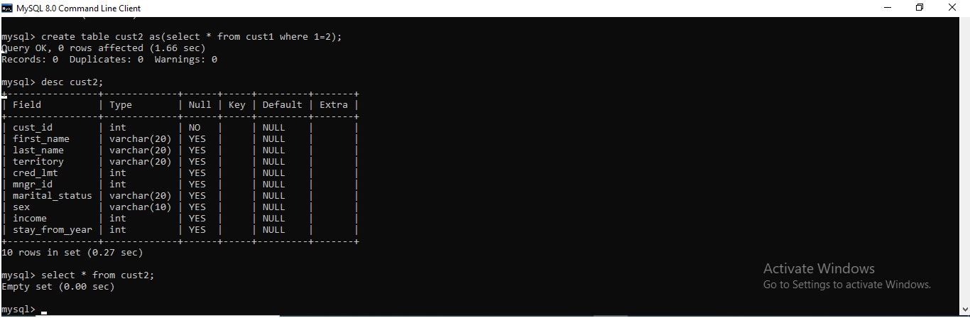

Q12. Create tables cust4 with attributes name customer_id, firstname, lastname, income from old customer table(using CTAS statement).

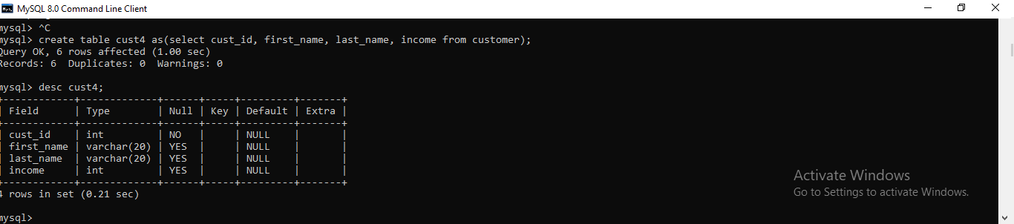

Q13. Drop column income from cust1

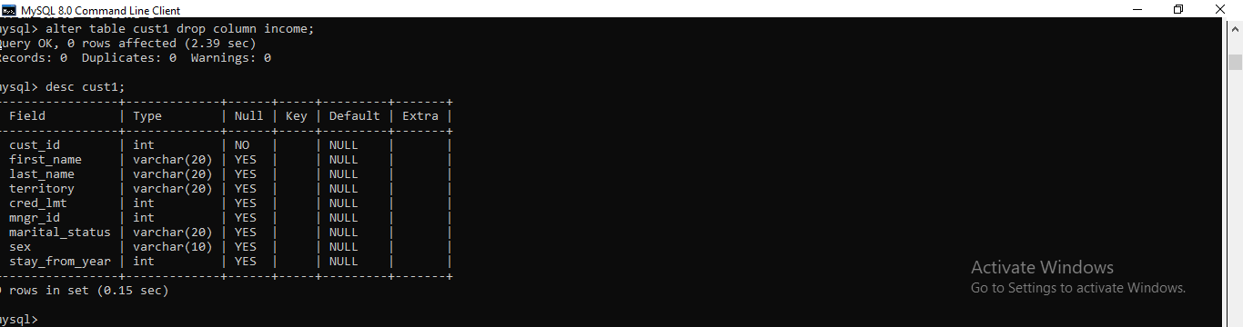

Q14. Rename table cust1 to cust_one

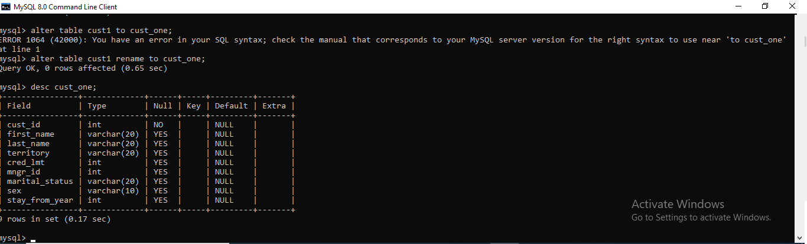

Q15. Insert values into cust2 table from customer table

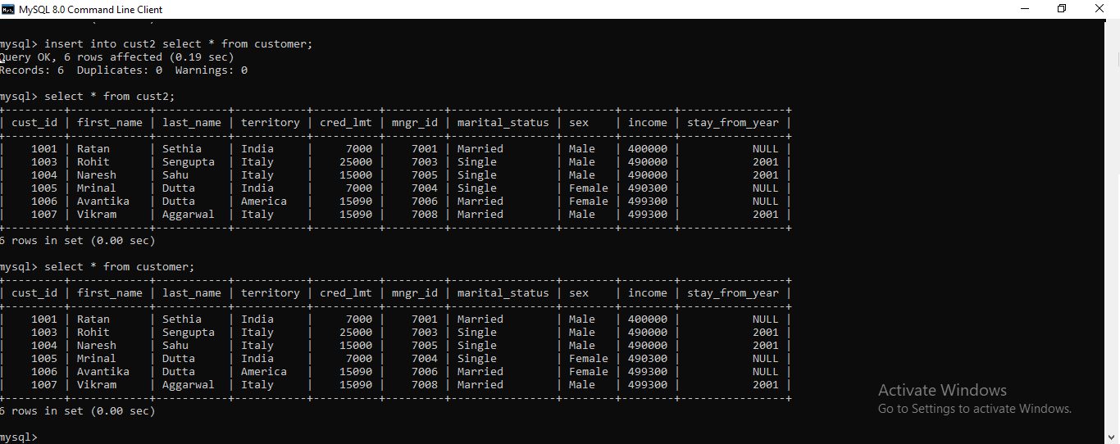

Q16. Delete all values from table cust1 where mngr_id is 7001

